BioBand Hardware Description
Chris Jones, Martin-Jones Technology Ltd
September 2011

Circuit description
The BioBand is based around an STM32F103C6T6 microcontroller, IC3. This device contains an ARM Cortex-M3 processor, 32kBytes of Flash memory, 10kBytes of RAM, various peripherals, and very low power consumption with excellent power management features. The processor samples data from IC2, a LIS331DLH three-axis accelerometer, and U4, a LM95071 temperature sensor via an SPI bus. It stores the data in IC6, a 4Gbit (512M by 8 bit) Flash memory chip.
The BioBand is powered by a Lithium Polymer battery, B1, which is charged by IC4, MAX1555EZK. U1, STM1001SWX6F, ensures that the processor is correctly reset at power-up, and IC5, ZXCL280H5TA, reduces the battery voltage to a regulated 2.8V to power the electronics. D1 is a tri-colour LED (HSMF-C114) which is used to indicate when the battery is charging and for other mode indications depending on the software.
The microcontroller IC3 has a USB device interface which is supported by some peripheral components including Q1, which ensures that the 1.5kOhm enumeration resistor R4 can only be enabled when both USB VBUS is present and nUSB_PULLUP is asserted. Connection to the outside world is via the Molex ‘Handylink’ connector J1, which carries the USB port, debug serial interface, JTAG interface for programming, and power for battery charging. U2 and U3 protect all relevant pins of J1 from electrostatic discharge damage, and give some measure of stopper resistance to improve electromagnetic compatibility.
The component U5 is a dummy part, substituted with a 0R resistor on the PCB, which makes the netlist palatable to the XJTAG boundary scan test tool. It is required because IC3 contains two boundary scan TAPs (Test Access Points) in its JTAG chain, and XJTAG at the time of writing requires one component in the net list for each TAP.

Power architecture
The BioBand power architecture is shown in the diagram below.
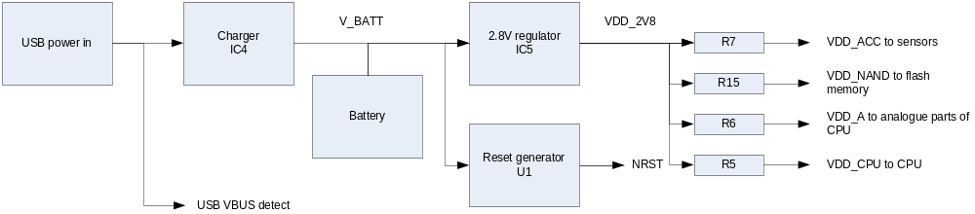
Power enters from the USB VBUS connection, nominally at 5V. A resistor network R1-R3 taps off a portion of this voltage to signal to the processor IC3 that the USB is connected. The VBUS power enters IC4 which controls charging of the battery. It limits the input current to less than 100mA, the maximum which can be drawn from an un-configured USB connection, and manages the charging of the battery to a maximum terminal voltage of 4.2V. It also provides an output when charging is taking place which is used to drive the green LED in versions 1.2 and 1.3 of the BioBand (not shown on the power architecture diagram).
Power from the battery, on the net V_BATT, feeds the reset generator U1 and regulator IC5. The reset generator asserts the NRST signal whenever the battery voltage falls below 2.93V, ensuring that the processor is shut down under this condition. It also makes sure that NRST is asserted for long enough to properly reset the processor when the battery voltage rises above this value during charging. The 2.93V threshold is chosen because it is the level below which IC5 can no longer deliver a stable output.
IC5 provides a 2.8V output, VDD_2V8, which powers the processor IC3, sensors IC2 and U4 and Flash memory IC6. It is a specially-chosen type with a low quiescent current of around 25µA to minimise battery drain. The choice of 2.8V was determined by it being below the normal minimum battery voltage (typically 3.0V) but still within the operating range of IC2, IC3, IC6 and U4.
The VDD_2V8 rail is distributed via resistors R7 (to the sensors IC2 and U4 via VDD_ACC), R15 (to the Flash memory IC6 via VDD_NAND), R6 (to the analogue supply of processor IC3 via VDD_A) and R5 (to the digital supply of processor IC3 via VDD_CPU). R6 is 10 ohms and gives some power supply filtering to the analogue parts of IC3. R5, R7 and R15 are all zero ohms and are included as convenient points at which the circuit can be broken to allow the current consumption of various parts to be measured.
The VDD_CPU rail is also fed to the connector J1 via 10k resistor R19. This signal is used as a reference voltage for external JTAG programming hardware. The resistor R19 is present to limit the current in the event of pin 1 of J1 being short-circuited to ground, which some pre-made Handylink cables do.

CPU GPIO allocation
The microcontroller IC3 has 37 general purpose I/O (GPIO) lines. Some of these can be configured to be connected to the microcontroller’s peripherals. This table lists the functions of each GPIO pin in the BioBand.
GPIO | Pin | Periph | I/O | Net | Description
PA0 | 10 | GPIO | I | VBUS_DET | High when USB VBUS is connected
PA1 | 11 | ADC | I | BATT_SAMPLE | Used to measure battery voltage
PA2 | 12 | GPIO | O | nUSB_PULLUP | Pull low to enable USB device to be enumerated by host
PA3 | 13 | GPIO | O | TEMP_NCS | Low to enable SPI access to temperature sensor U4
PA4 | 14 | GPIO | O | SPI_NSS | Low to enable SPI access to accelerometer IC2. Note that this pin is driven as a GPIO and not automatically by IC3’s SPI peripheral
PA5 | 15 | SPI | O | SPI_SCK | SPI clock
PA6 | 16 | SPI | I | SPI_MISO | SPI data from accelerometer IC2
PA7 | 17 | SPI | I/O | SPI_MOSI | SPI data to accelerometer IC2 and to/from temperature sensor U4
PA8 | 29 | GPIO | I/O | LED_G_NCHG | Input low when battery is charging. Can also be forced low as an output to light green LED
PA9 | 30 | GPIO  UART | O | LED_B_TXD | Low to light blue LED. Also serial data TXD during bootstrap loader operation
PA10 | 31 | GPIO  UART | I/O | LED_R_RXD | Low to light red LED. Also serial data RXD during bootstrap loader operation
PA11 | 32 | USB | I/O | D-INT | USB data
PA12 | 33 | USB | I/O | D+INT | USB data
PA13 | 34 | JTAG | I | TMS | JTAG programming port
PA14 | 37 | JTAG | I | TCK | JTAG programming port
PA15 | 38 | JTAG | I | TDI | JTAG programming port
PB0 | 18 | GPIO | O | NAND_NCE | Chip Enable to Flash IC6
PB1 | 19 | GPIO | O | NAND_NWE | Write Enable to Flash IC6
PB2 | 20 | GPIO | O | NAND_NRE | Read Enable to Flash IC6
PB3 | 39 | JTAG | O | CPU_TDO | JTAG programming port
PB4 | 40 | JTAG | I | TRST | JTAG programming port
PB5 | 41 | GPIO | O | NAND_CLE | Command Latch Enable to Flash IC6
PB6 | 42 | GPIO | O | NAND_ALE | Address Latch Enable to Flash IC6
PB7 | 43 | GPIO | I | NAND_RNB | Ready Not Busy from Flash IC6
PB8 | 45 | GPIO | I/O | NAND_D0 | Data to/from Flash IC6
PB9 | 46 | GPIO | I/O | NAND_D1 | Data to/from Flash IC6
PB10 | 21 | GPIO | I/O | NAND_D2 | Data to/from Flash IC6
PB11 | 22 | GPIO | I/O | NAND_D3 | Data to/from Flash IC6
PB12 | 25 | GPIO | I/O | NAND_D4 | Data to/from Flash IC6
PB13 | 26 | GPIO | I/O | NAND_D5 | Data to/from Flash IC6
PB14 | 27 | GPIO | I/O | NAND_D6 | Data to/from Flash IC6
PB15 | 28 | GPIO | I/O | NAND_D7 | Data to/from Flash IC6
PC13 | 2 | GPIO | I | ACC_INT | Interrupt from Accelerometer IC2
PC14 | 3 | LSE | I | OSC32_IN | 32.768kHz crystal for real time clock
PC15 | 4 | LSE | O | OSC32_OUT | 32.768kHz crystal for real time clock
PD0 | 5 | HSE | I | OSC_IN | 16MHz crystal for processor clock
PD1 | 6 | HSE | O | OSC_OUT | 16MHz crystal for processor clock

Connector pinout
The connector J1 has 16 pins. They are numbered starting with pin 1 at the right hand end when looking at the connector with the PCB downwards and the Flash chip IC6 facing upwards.
Pin | Net | Description
1 | VDD_CPU_EXT | 2.8V CPU supply via 10k resistor. Used as voltage reference for JTAG programming
2 | RXD_EXT | Serial data input for bootstrap programming (see BOOT0 below)
3 | TXD_EXT | Serial data output for bootstrap programming (see BOOT0 below)
4 | GND | Ground
5 | D+EXT | USB data
6 | D-EXT | USB data
7 | V_BUS | USB VBUS, used to detect presence of USB and charge battery
8 | GND | Ground
9 | NRST_EXT | Pull low to reset. Also used by JTAG
10 | TDI_EXT | JTAG
11 | TMS_EXT | JTAG
12 | TCK_EXT | JTAG
13 | TDO_EXT | JTAG
14 | TRST_EXT | JTAG
15 | BOOT0_EXT | Boot selection. Take this pin high during reset to force the internal bootstrap loader to run instead of the programmed firmware
16 | GND | Ground
This arrangement of pins has been chosen for compatibility with pre-made Molex Handylink USB cables, Molex part numbers 366970021, 366970022 and 366970023. These cables connect pins 1 and 16 together, which is why pin 1 has a 10k current-limiting resistor from VDD_2V8.
The pin arrangement should also result in no damage if a cable part number 366970024 is plugged in, though the USB connection on this cable will not work.

Programming board
The programming board brings out the pins of the Handylink connector J1 to industry standard power, USB, serial and JTAG connections. It also exposes NRST as a pushbutton and BOOT0 as a link. It is fitted with both male and female Handylink connectors so that a BioBand can be plugged directly into it or via a male-to-male Handylink cable.
The programming board exists in two versions. See the ‘connector pinout’ section above for details of why the difference in handling of pin 1 exists. The versions are:
- Version 1.0 uses VDD_CPU directly from J1 pin 1 to feed to the JTAG socket’s reference pin. Any JTAG dongle attached to this socket may draw some current (several milliamps) from this pin to power its output buffers. Only versions 1.0 and 1.1 of the BioBand have J1 pin 1 connected directly to VDD_CPU and are thus compatible with JTAG programming on programming board version 1.0.
- Version 1.2 contains a buffer connected to J1 pin 1 which then feeds the JTAG socket’s reference pin. This means that it is compatible with all versions of the BioBand including versions 1.2 and 1.3 which have a 10k resistor fitted between VDD_CPU and J1 pin 1.
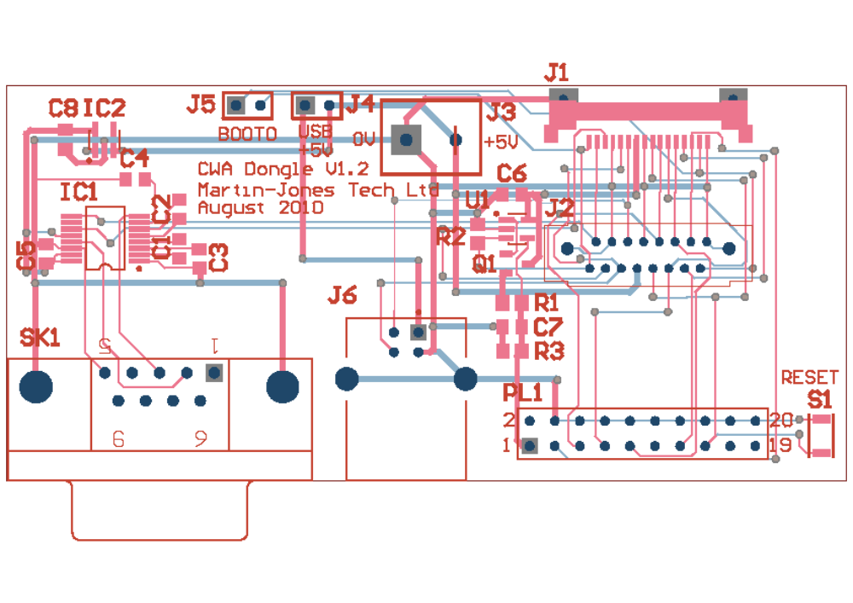The connectors on the board are:
- SK1, the serial port. This is a standard 9-pin female D-type connector, wired so that it can be connected straight to a typical USB-to-serial converter or via a straight-wired male-female cable to a PC serial port. Note that a track layout error on BioBand version 1.2 boards prevents the serial port from working. The serial port is intended to be used for bootstrap programming using the STMicroelectronics bootstrap loader which is activated if the BOOT0 link is made when the BioBand is reset using the NRST button.
- J6, the USB port. This is connected to the BioBand’s USB interface. It is a device port and can only be connected to a USB host such as a PC. The programming board contains a link, J4, which must be made in order to connect the USB port’s VBUS connection to the BioBand and allow the battery to charge from USB.
- PL1, the JTAG connector. This connector has the standard ARM JTAG pinout and is directly compatible with many JTAG tools such as the Amontec JTAGKey and the XJTAG XJLink.
- J1 and J2, the BioBand connectors. J1 needs a male-to-male Handylink connector while J2 can plug straight into a BioBand.
- J3, the 5 volt power connector. This is wired to USB_VBUS on pin 7 of the BioBand and can be used as a source of power to charge the BioBand’s battery. It is useful when it is desired to keep the BioBand powered when plugging and unplugging the USB connection, for example, or to measure the charging current. The link J4 connects USB_VBUS also to the USB connector J6. Take care not to connect both power sources at the same time with J4 fitted because damage may result.
The switches and links are:
- S1, the reset switch. Pressing this button resets the BioBand.
- J4, the power link. This connects 5V power from the USB connector to the BioBand’s VBUS input and must be fitted if the BioBand’s battery is to be charged from the USB port.
- J5, the BOOT0 link. If this link is fitted when the reset button is pressed, the BioBand will start its serial boot loader which can be accessed through the serial port SK1.

XJTAG testing
XJTAG boundary scan tests have been prepared for the BioBand board, which mean that its basic hardware functionality can be tested on the production line without loading any software into it. The tests cover the following items:
- Connection test. Checks that none of the pins of the IC3 which can be accessed by boundary scan are shorted together.
- NAND Flash. Reads the manufacturer and device IDs from IC6, which verifies that read and write operations work and that all data bus bits are present and correct.
- Accelerometer. Checks that device ID can be read from IC2 and executes its internal self-test, which applies a known force to the accelerometer. Verifies that the deflection readings for each axis are within reasonable limits and thus that the accelerometer is likely to be working properly.
- Temperature sensor. Reads device ID from U4 and checks that it is correct. Also reads the current temperature in degrees Celsius and displays it.
- USB interface. This test can only be performed if USB_VBUS is connected. It simply checks that Q1 can correctly pull up D+ and release it.
- LED. This flashes each of the red, green and blue LEDs and asks the tester to confirm each one.

